PROGRAMMING PRACTICE LAB



Name :- Anubhab Rakshit
Class :- BCSE-II
Sec :- A1
Roll Number :- 002410501029

INDEX

Sl. No | Description | Pg. No
1 | Assignment –1 (Cover) | 3
2 | Q1 | 4
3 | Q2 | 5 - 6
4 | Q3 | 6 - 10
5 | Q4 | 11 - 15
6 | Q5 | 16 - 17
7 | Q6 | 18 - 19
8 | Q7 | 19 - 22
9 | Q8 | 23 - 25
10 | Assignment – 2 (Cover) | 26
11 | Q1 | 27 - 36

ASSIGNMENT - 3
1. Write a function swap(a,b) to interchange the values of two variables . Do not use pointers .

#include <iostream>
using namespace std;

pair<int,int> swap(int a,int b){
return {b,a}; //swapping values returning as pair
}

int main(){
int a,b;
cout<<"Enter your value a and b :- ";
cin>>a>>b;
pair <int,int> x=swap(a,b);
a=x.first;
b=x.second;
cout<<"a = "<< a << " b = " << b << endl;
return 0;
}

OUTPUT :-

2. Write a function max(a,b) that will return the reference of larger value . Store the returned information to x
where x is a i) variable of type a or b ii) variable referring to type a or b . In both the cases modify
x. Check also the values of a and b.

#include <iostream>
using namespace std;

int max(int a,int b){ //passing value
if (a>b){
return a;
}
else{
return b;
}
}

int& max_ref(int &a,int &b){ // passing reference
if (a>b){
return a;
}
else{
return b;
}
}
int main(){
int a,b;
cout<<"Enter your elements :- ";
cin>>a>>b;
int x=max(a,b);
cout<<"Max of them x = "<<x<<endl;
int &y=max_ref(a,b);
cout<<"Max of them by reference type x = "<<y<<endl;
return 0;
}

OUTPUT:-

3. Write a function that will have income and tax rate as arguments and will return tax amount. In case tax
rate is not provided it will be automatically taken as 10%. Call it with and without taxes.

#include <iostream>

using namespace std;
float calc(float income,float tax=10.0){ //function for calculating tax amount
return (tax*income)/100.0;
}
int main(){
float income;
cout<<"Enter your income :- ";
cin>>income;
cout<<"Do you have a predefined tax rate 0=yes 1=no :- ";
int ch;
cin>>ch;
float tax_amt;
if(ch==0){
cout<<"Enter your tax rate :- ";
float rate;
cin>>rate;
tax_amt=calc(income,rate); //calling with custom tax rate
}
else{
tax_amt=calc(income); //calling with default tax rate
}

cout<<"Calculated tax amt :- "<<tax_amt<<endl;
return 0;
}

4.Write a function void f(int) that prints "inside f(int)" . Call the function with actual argument of type
i) int , ii) char iii) float and iv) double. Add one more function f(float) that prints "inside f(float)" .
Repeat the calls again and observe the outcomes.

#include <iostream>
using namespace std;

void f(int a){
cout<<" inside f(int) \n";
}

void f(float a){
cout<<" inside f(float)\n";
}
int main(){
cout <<"int : ";f(12); // passing int
cout <<"char : ";f((char)'a'); // passing char but c++ takes it as int
cout <<"float : ";f((float)8); // passing float

}

5. Define functions f(int,int) and f(char,int). Call the functions with arguments of type (int,char),
(char,char) , (float,float) . Observe and analyze the outcome.

#include <iostream>

using namespace std;

void f(int a,int b){
cout<<"Inside f(int,int) \n";
}
void f(char a,int b){
cout<<"Inside f(char,int) \n";
}
int main(){
cout<<"Passing (int,char) ";f(12,'c'); //passing int ,char
cout<<"Passing (char,int) ";f('a',123); // passing char ,int
//cout<<"Passing (float,float)";f((float)12,(float)26.5);
return 0;
}

6.Define a structure student with roll and score as attributes and with two member functions to take input
and to show the data. Use the member functions to take data for a structure variable and to show. Write global
function i) to modify score and ii) to show the data again

#include <iostream>

using namespace std;

typedef struct { //defining student struct
int roll;
float score;
void input(){ // input data
cin >> roll >> score;
}
void display(){ // display data
cout<<"Data : Roll :- "<<roll<<" Score :- "<<score<<endl;
}
}student;

void modify(student &s){ //modify student data
int roll;
float score;
cout<<"Enter the modified student roll number and score";
cin>>roll>>score;
s.roll=roll; //re assigning the data
s.score=score;
}
int main(){
student s;
cout<<"Enter roll and score :- ";
s.input(); //calling for data input
s.display(); //calling for display
int ch;
cout<<"Do you want to modify score ? 0 for yes 1 for no ";
cin>>ch;
if(ch==0){
modify(s); //calling for modify func
s.display();
}
else{
cout<<"Not modified!";
}
}

7.Design a class TIME which stores hours,minute and second. The class should have the methods to support the followings:
* User may give the time value in 24-hour format
* User may give the time value in AM/PM format
* Display the time in 24-hour format
* Display the time in AM/PM format
* User may like to add minute with a time value

#include<iostream>
#include<string>

using namespace std;

class TIME{
int second;
private:

void twenty_four(){

cout << "Enter in the format (eg-12 34 56 AM or 23 34 43)\n";
int hr,min;

string s;
getline(cin,s);

hr = (s[0]-'0')*10 + (s[1]-'0');
min = (s[3]-'0')*10 + (s[4]-'0');
second = (s[6]-'0')*10 + (s[7]-'0');
if(s.length()>8){
if(s[9] == 'P' && hr<12){
second += 12*3600;
}
}
second += min*60 + 3600*(hr-1);
}

void output_twelve() {
int temp = second;
int p = (temp+3600)/(12*3600);
p%=2;
temp %= (12*3600);
string last = (p?"PM":"AM");
int hr = temp/3600;
hr++;
temp %= 3600;
int min = temp /60;
// Forward declaration is necessary because Account and Withdraw reference each other.
temp%=60;
int sec = temp;
cout << "Time : " << hr << " " << min << " " << sec << " " << last << "\n";

}

void output_twenty4(){
int temp = second;
temp %= 24*3600;
int hr,min,sec;
hr = temp/3600;hr++;
hr%=24;
temp%=3600;
min = temp/60;
temp%=60;
sec = temp;
cout << "Time : " << hr << " " << min << " " << sec << "\n";
}

public :
void input(){
twenty_four();
}

void output(){
cout << "Enter 1 to display in 24hr format and 2 for 12hr format\n";
int t;
cin>>t;

if(t==1) output_twenty4();
else output_twelve();

}

void edit(){

int min;
printf("Enter minute to add : ");
cin>>min;
second += 60*min;

}

};

int main(){

TIME time;
printf("Enter the time \n");
time.input();

int t=1;
while(1){

cout << "Enter 1 to display and 2 to edit anything else\n";
cin>>t;
if(t==1) time.output();
else if(t==2) time.edit();

else return 0;
}
}
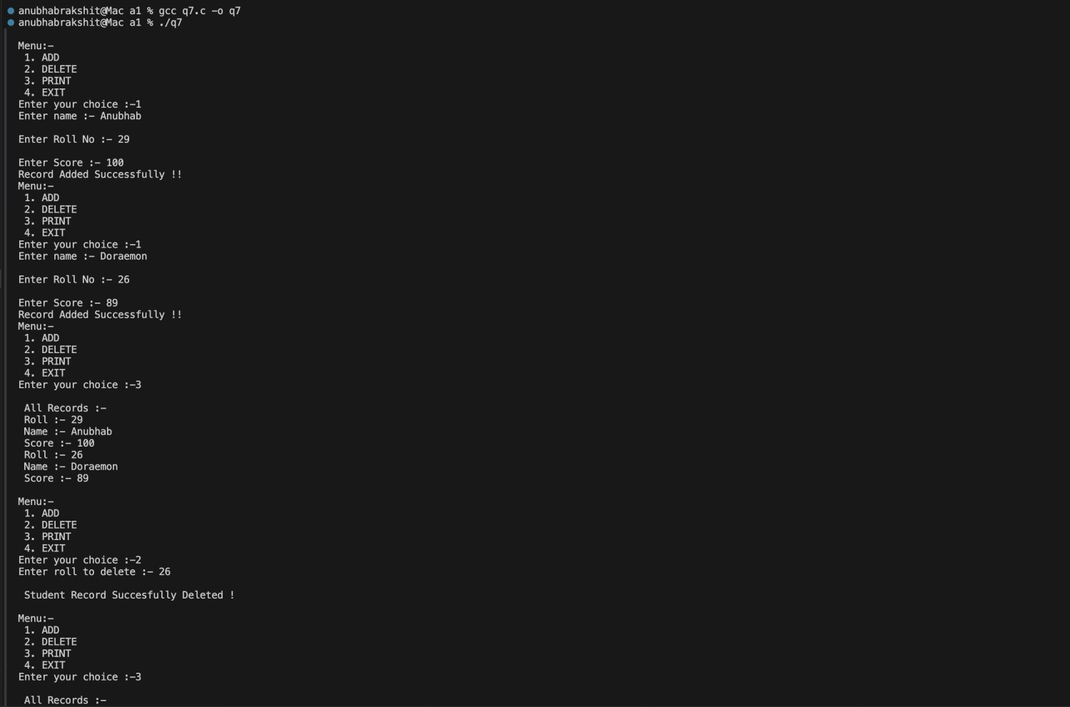
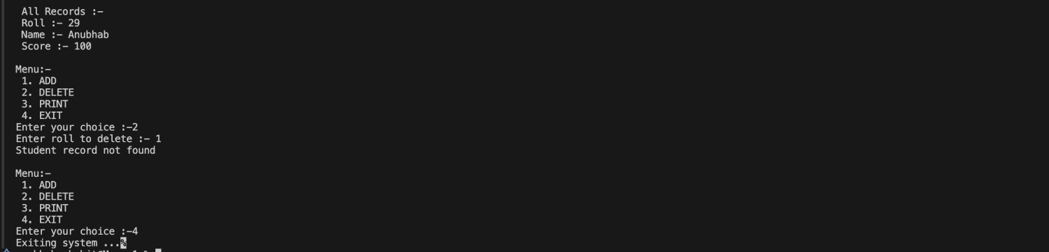
OUTPUT :-

Consider an array that stores roll, name, and score of number of students. Develop a function to sort the array. User of sort() will develop the comparison function for sorting on roll/score and ascending or descending order and reuse the same sort() function.

#include <stdio.h> #include <stdlib.h> #include <string.h> #include <stdbool.h>

// structure to hold student details typedef struct {
int roll;
char name[100]; int score;
} Student;

// generic sort function using function pointer
void sort(Student *arr, int n, bool(*fp)(Student, Student)) { for (int i = 0; i < n - 1; i++) {
for (int j = i+1; j < n; j++) { if (fp(arr[i], arr[j])) {
Student temp = arr[i]; arr[i] = arr[j];
arr[j] = temp;
}
}
}
}

// comparison functions
bool rollAsc(Student a, Student b) { return a.roll > b.roll; } //logic defination bool rollDesc(Student a, Student b) { return b.roll > a.roll; }
bool scoreAsc(Student a, Student b) { return a.score > b.score; } bool scoreDesc(Student a, Student b) { return b.score > a.score; }

// print student array
void display(Student *arr,int n) { printf("\nStudent Records\n"); for (int i = 0; i<n; i++) {
printf("Roll: %d, Name: %s, Score: %d\n",arr[i].roll, arr[i].name, arr[i].score);
}
}
int main() { int n;
printf("Enter number of students: "); scanf("%d", &n);

Student *arr = (Student*)malloc(n * sizeof(Student));

// input student details for (int i = 0; i < n; i++) { printf("Enter roll: ");
scanf("%d", &arr[i].roll); printf("Enter name: "); getchar(); // clear newline scanf("%[^\n]s", arr[i].name); printf("Enter score: "); scanf("%d", &arr[i].score);
}

// menu loop while(1){
int ch;
printf("\nSort by :- \n1. Roll-Ascending \n2. Roll-Descending \n3. Score-Ascending \n4. Score- Descending\n");
scanf("%d", &ch);

switch (ch){
case 1: sort(arr,n,rollAsc); break; // call roll ascending case 2: sort(arr,n,rollDesc); break; // call roll descending case 3: sort(arr,n,scoreAsc); break; // call score ascending
case 4: sort(arr,n,scoreDesc); break; // call score descending default:
printf("Invalid choice\n"); free(arr);
exit(0);
}
display(arr, n);
}

free(arr); // cleanup (unreachable but good practice) return 0;
}
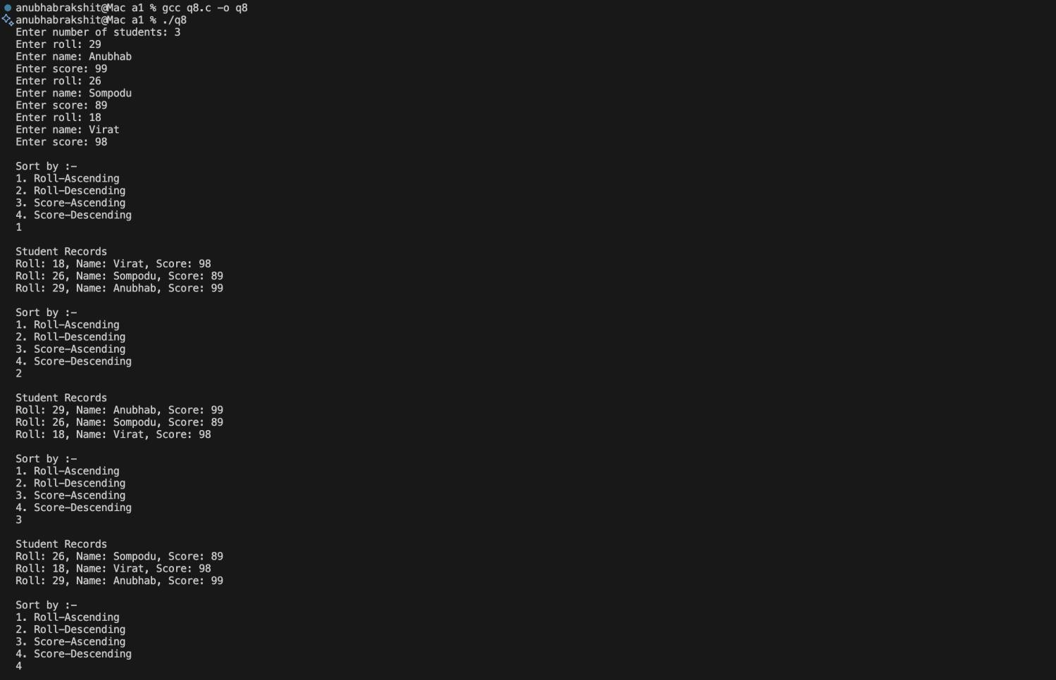
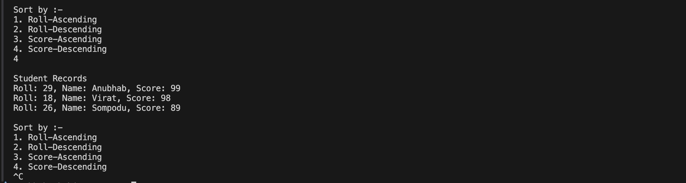
OUTPUT :-

ASSIGNMENT - 2

Write a program to store student information in a file and to do the following operations. Information includes roll, name, and score in five subjects. Use may like to add record (check if roll number is unique), display all records showing roll, name and total score. User may search for the record against a roll.
User may edit the details in a record.User may delete record. Deletion may be logical (by some means indicate it is an invalid record and to be avoided in processing) and physical(file will not have the record ).

#include <stdio.h> #include <stdlib.h> #include <stdbool.h> #include <string.h>

//defining student structure typedef struct {
int roll;
char name[41]; int marks[5];
int deleted; // 0 = active, 1 = logically deleted
} Student;

bool isRollUnique(char* ,int ); void add(char *filename) {
Student s;
//opening file in append and binary mode FILE *fp = fopen(filename, "ab+"); if(fp==NULL){
printf("Error opening file!\n"); return;
}

//input
printf("Enter roll no :- "); scanf("%d",&s.roll);
//checking for unique roll number if(!isRollUnique(filename,s.roll)){ printf("Roll number already exists!\n"); fclose(fp);
return;
}

//input name and marks printf("Enter name :- "); getchar();

scanf("%[^\n]s",s.name);
printf("Enter marks in 5 subjects :- \n"); for (int i=0;i<5;i++) {
scanf("%d", &s.marks[i]);
}

//setting variable active s.deleted = 0; fwrite(&s,sizeof(Student),1,fp); printf("Record added\n");

fclose(fp);
}

void display(char *filename) { // display function FILE *fp = fopen(filename, "rb");
if (fp==NULL) {

printf("No file found!\n"); return;
}

Student s;
printf("\nDetails in file :- \n");
while (fread(&s, sizeof(Student), 1, fp)) {
if (!s.deleted) { // not temporarily deleted int total = 0;
for (int i = 0; i < 5; i++) {
total += s.marks[i]; // summation of marks
}
printf("Name :- %s\n", s.name);
printf("Roll :- %d\n", s.roll); printf("Total :- %d\n\n", total);
}
}

fclose(fp);
}

void search(char *filename) { // search function int roll,f=0;

FILE *fp = fopen(filename, "rb"); if (!fp) {
printf("File doesn't exist!\n"); return;
}

printf("Enter roll to search: "); scanf("%d", &roll);

Student s;
while(fread(&s, sizeof(Student), 1, fp)){ //reading till end of file

if (s.roll==roll && !s.deleted) { //roll matched and not temporarily deleted

printf("Record Found!\n Roll :- %d\nName :- %s\nMarks :- ", s.roll, s.name); for (int i=0;i<5;i++){
printf("%d ",s.marks[i]);
}
printf("\n"); f=1;
break;
}
}

if (f==0) {
printf("Record not found!\n");
}
fclose(fp);

}
void edit(char *filename){ //edit data in function int roll, f=0;
FILE *fp = fopen(filename, "rb+"); if (fp==NULL) {
printf("File not found!\n"); return;
}

printf("Enter roll to edit: "); scanf("%d", &roll);
Student s;
while (fread(&s, sizeof(Student), 1, fp)) {

if (s.roll == roll && !s.deleted) { //data to be edited (found) f=1;
printf("Enter new name :- "); getchar(); scanf("%[^\n]s",s.name);
printf("Enter new marks for all subjects :- "); for (int i=0;i<5;i++)
{
scanf("%d", &s.marks[i]);
}
fseek(fp, -sizeof(Student), SEEK_CUR); // moving cursor back with sizeof(Student) fwrite(&s,sizeof(Student),1,fp); // writing new data
printf("Record updated\n"); break;
}
}

if (f==0)
{
printf("Record not found!\n");
}
fclose(fp);
}
void logicalDelete(char *filename) { //logical deletion function (stays in file but is deleted) int roll, f= 0;
FILE *fp = fopen(filename, "rb+"); if (fp==NULL) {
printf("File not found!\n"); return;
}

printf("Enter roll to logically delete :- "); scanf("%d", &roll);

Student s;
while (fread(&s,sizeof(Student),1,fp)) { if (s.roll==roll && !s.deleted) {
s.deleted = 1; // changing from 0 to 1 , here 0 is not logically deleted and 1 is logically deleted fseek(fp, -sizeof(Student), SEEK_CUR); // moving cursor back by 1 * sizeof(Student) fwrite(&s,sizeof(Student),1,fp); // writing new data
printf("Record logically deleted\n"); f=1;
break;
}
}

if(f==0)
{
printf("Record not found\n");
}
fclose(fp);
}
void physicalDelete(char *filename) { // physical deleting all data which are logically deleted FILE *fp = fopen(filename, "rb");
FILE *temp = fopen("temp.dat", "wb"); // temporarily creating a new file
if (fp==NULL||temp==NULL) { printf("Error \n");
return;
}
//manually only storing elements that are not logically deleted Student s;
while (fread(&s,sizeof(Student),1,fp)) { if(!s.deleted)
{
fwrite(&s,sizeof(Student),1,temp);
}
}

fclose(fp); fclose(temp);
remove(filename); //removing original file
rename("temp.dat", filename); //renaming temp file to original file printf("Physical deletion completed!\n");
}
bool isRollUnique(char* filename,int roll){ FILE *fp = fopen(filename, "rb");
if (fp==NULL)
{
return 1; // no file means unique
}
Student s;
while (fread(&s,sizeof(Student),1,fp)) { if (s.roll==roll &&!s.deleted) {
fclose(fp); return false;
}
}

fclose(fp); return true;
}

int main(int argc,char *argv[]) { // passing filename as command line arguments int ch;
while (1) {
//final menu for operations printf("\nMenu:\n"); printf("1.Add Record\n"); printf("2.Display Records\n"); printf("3.Search by Roll\n"); printf("4.Edit\n"); printf("5.Logical Delete\n"); printf("6.Physical Delete\n"); printf("7.Exit\n");
printf("Enter: ");
scanf("%d", &ch);

switch (ch) { case 1:
add(argv[1]); // call add data function

break; case 2:
display(argv[1]); // call display data function break;
case 3:
search(argv[1]); // call search data function (search data by roll) break;
case 4:
edit(argv[1]); // call edit data function (edit data by roll) break;
case 5:
logicalDelete(argv[1]); // call logical delete function (delete by roll) break;
case 6:
physicalDelete(argv[1]); // call physical delete function (removes from file) break;
case 7:
exit(0); // exiting the system default: printf("Invalid choice!\n");

}
}
return 0;
}

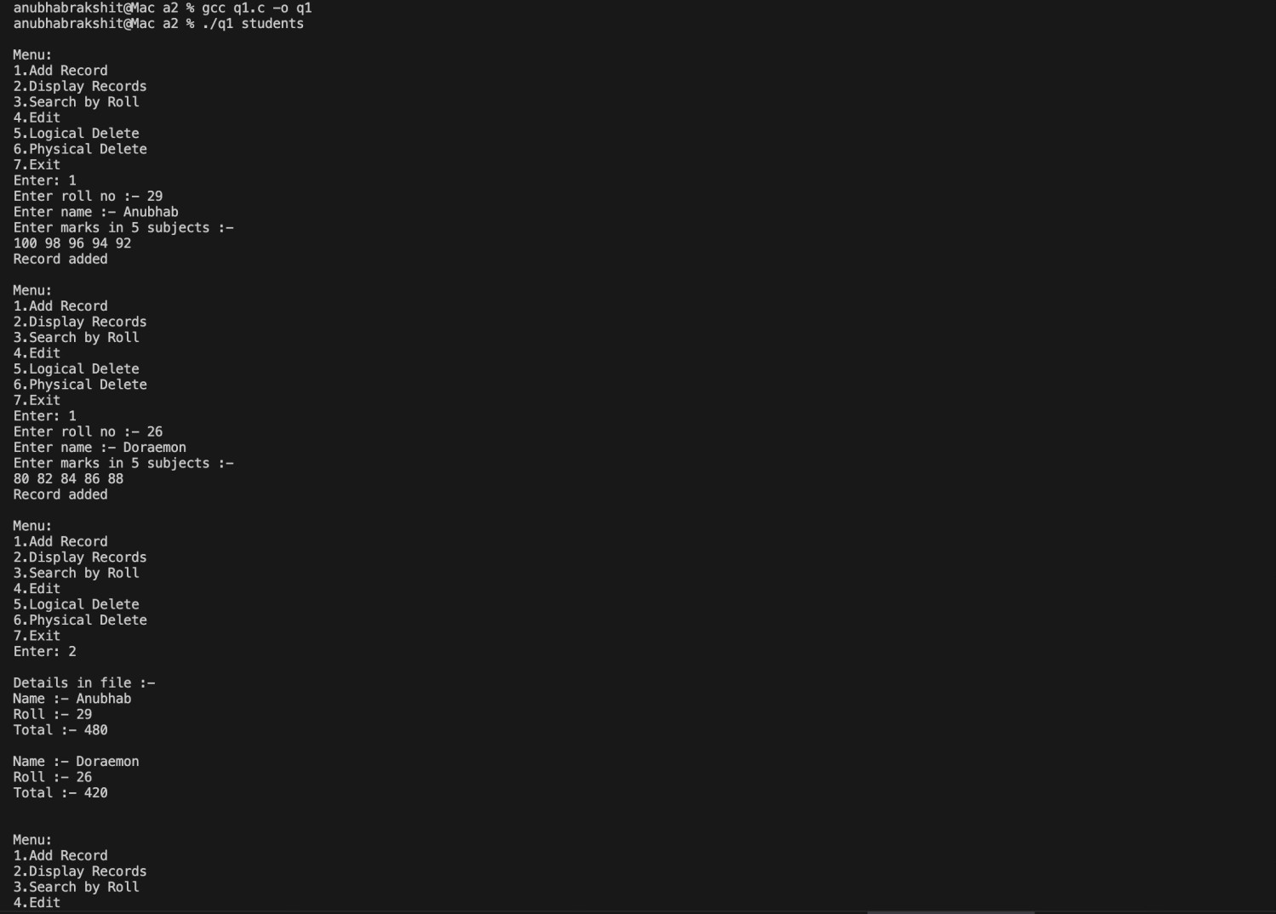
OUTPUT :-
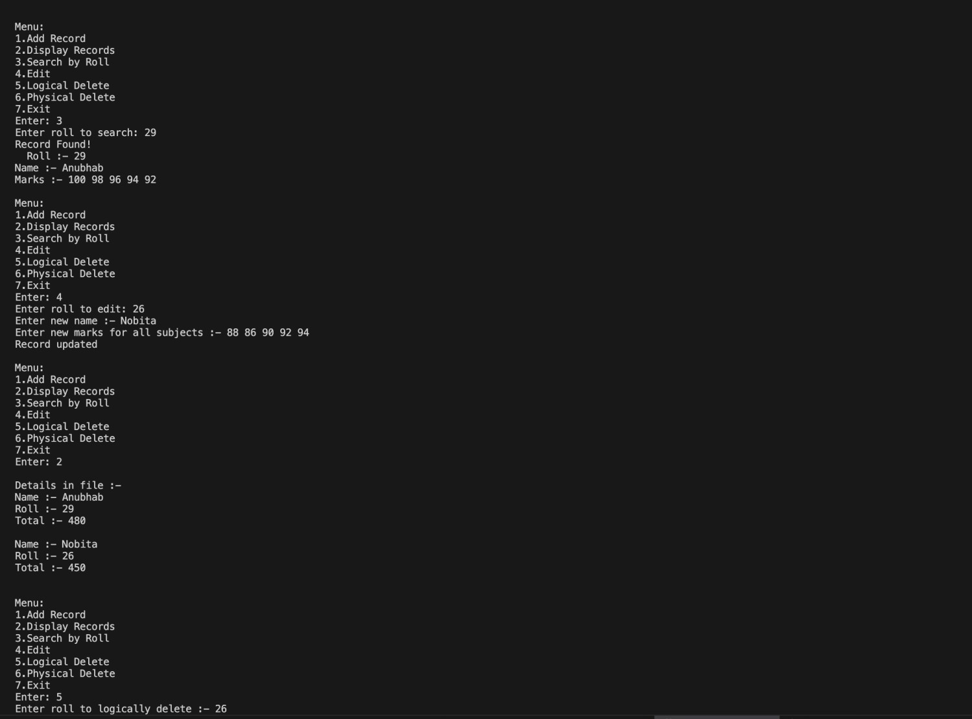
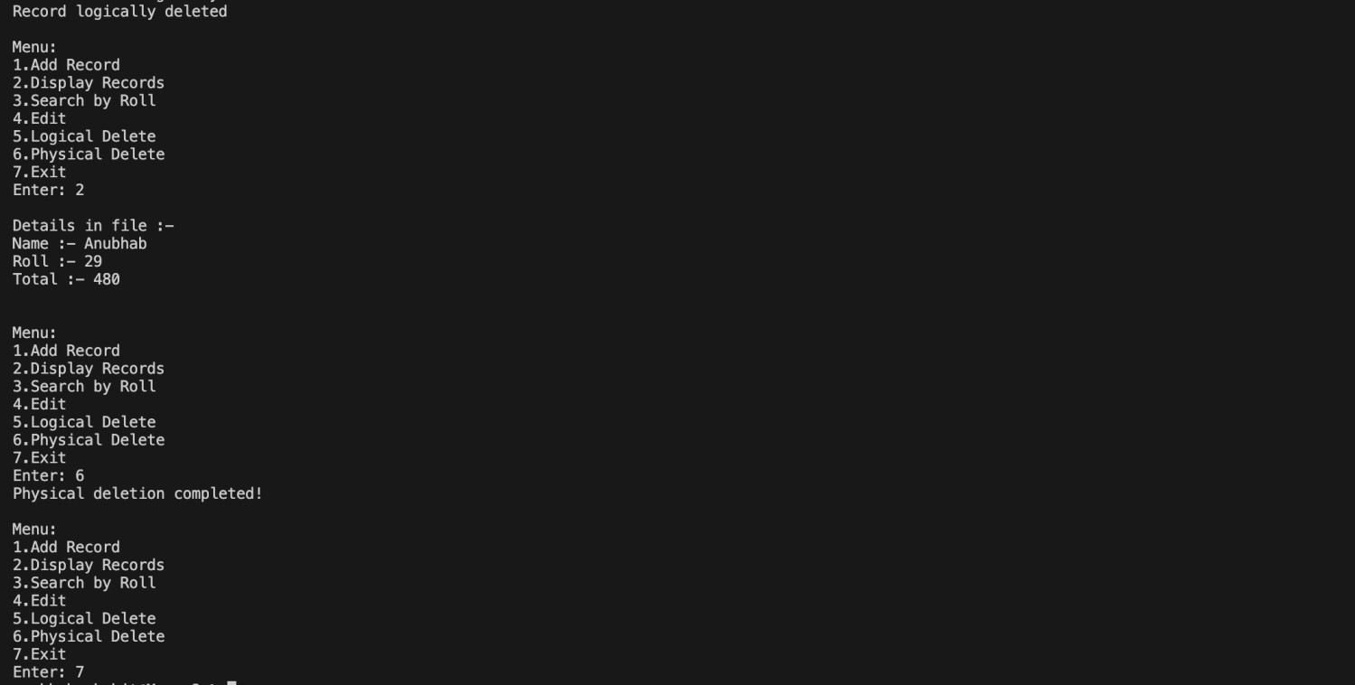

THESE PROGRAMS HAS BEEN CHECKED TILL THE LAST LAB CLASS

